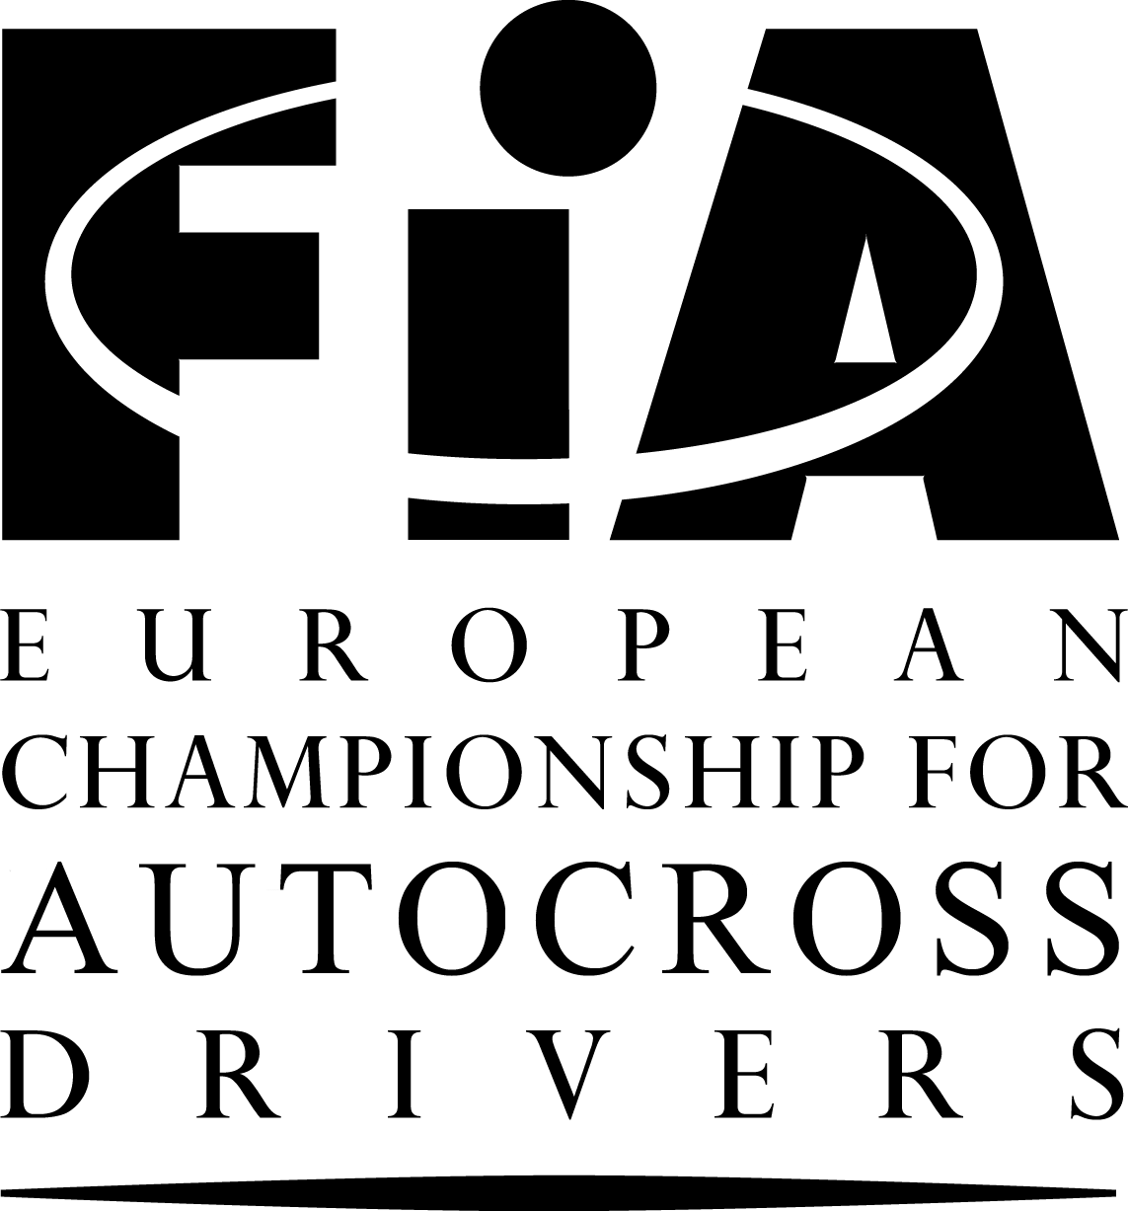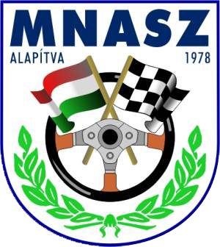

SUPPLEMENTARY
REGULATIONS FOR EVENTS OF THE FIA EUROPEAN CHAMPIONSHIP
FOR AUTOCROSS DRIVERS

Nyirád Motorsport Centrum (Hungary)
20/21 August, 2011

This document contains the particularities of the event and is based on the currently valid Appendices to the International Sporting Code and on the newest version of the Standard Regulations for Events of the FIA European Championship for Autocross Drivers. For all articles not specified in this document, the Standard Regulations for Events of the FIA European Championship for Autocross Drivers are valid. The Standard Regulations are distributed to each competitor in the FIA European Championship by his ASN. They are also posted on the Official Notice Board of each event. The numbering of the chapters is in accordance with the Standard Regulations.

CHAPTERS:

I. PROGRAMME
II. ORGANISATION: Article 1
III. GENERAL CONDITIONS: Articles 2-8
IV. CHECKING: Articles 9-10
V. RUNNING OF THE EVENT: Articles 11-17
VI. PARC FERME / RESULTS / PROTESTS: Articles 18-20
VII. PRIZES AND CUPS: Article 21
VIII. OTHER INFORMATION: Articles 22-25

I. PROGRAMME

20 June 2011 | Publication of regulations and acceptance of entries
6 August 2011 | Closing date for entries at normal fee (1st closing date)
12 August 2011 | Closing date for entries at increased fees (2nd closing date)

19 August 2011, Friday
16:00-19:30 | Secretariat and Scrutineering will be open
17:00-19:00 | Administrative checking (Paddock, Building “8”)
17:10-19:10 | Scrutineering (optional) (Paddock, Builing “9”)

20 August 2011, Saturday
7:00-19:00 | Secretariat will be open
7:30-9:30 | Administrative checking (Paddock, Building “8”)
7:40:9:50 | Scrutineering (Paddock, Builing “9”)
10:30 | First Stewards Meeting
11:00-13:00 | Free practice
13:00-16:00 | Official timed practice
10 min. after Official timed practice | Second Stewards Meeting
16:30 | 1st Heat begins

21 August 2011, Sunday
8:00-19:00 | Secretariat will be open
9:00 | 2nd Heat begins
11:30 | 3rd Heat begins
10 min. after Official timed practice | Third Stewards Meeting
14:00-14:30 | Presentation of nations
14:30-15:00 | Motor and air-show
15:00 | Finals
After each “A” Finals | Podium (Iron structured hall, Building “X”)
10 min. after the end of the Finals | Fourth Stewards Meeting
17:30 | Official Prize Giving (Iron structured hall, Building “X”)

II. ORGANISATION
1.1 The Nyirád Motorsport Kft. will organise an FIA European Autocross Championships Event. This Event will be run in accordance with the Code (and its Appendices) of the FIA, the FIA Regulations for Autocross, General Prescriptions for the Championship and these Regulations (and any other Regulations which may be issued in writing by the organisers).

1.2 Organising Committee
Boglárka BUDAI (Chairman), István PUSKÁS, Dr. Zoltán PÁLL, Ferenc BUDAI, Istvánné TATOS, Márta ZUBAI, Tibor LASKAI.

Secretariat: Nyirád Motorsport Kft.
Postal Address: H-2101 Gödöllő 1, Pf. 142.
Telephone: +36 30 6595758
Fax: +36 1 4110096
Email: nyiradmotorsport@gmail.com
Website: www.nymc.eu

1.3 Officials
- Chairman of the Stewards Mr. Milan TEJCHMAN Czech Rep.
- Steward Mr. Péter FALUVÉGI Hungary
- Steward Mr. Jean-Paul MAILLARD France
- FIA Observer Mr. Wlodek SZANIAWSKI Poland
- FIA Technical Delegate Mr. Lutz SPEER Germany
- Clerk of the Course Mr. Béla MIGÁLY Hungary
- Assistant Clerk of the Course Mr. Vilmos CSELÉNYI Hungary
- Secretary to the Stewards Ms. Márta ZUBAI Hungary
- Secretary of the meeting Ms. Boglárka BUDAI Hungary
- Chief Scrutineer Mr. Balázs CSELÉNYI Hungary
- Chief Timekeeper Mr. Václav PISTEK Czech Rep.
- Safety Officer Mr. István PUSKÁS Hungary
- Chief Medical Officer Mr. Zoltán PÁLL Hungary
- Drivers' Liaison Officer Mr. István MÓNI Hungary
- Press Officer Mr. Ferenc BUDAI Hungary
- Judges of fact: - startline Mr. Gergely ÉRI Hungary
- false Start Ms. Magdolna DEMETER Hungary
- finish Mr. Gergely ÉRI Hungary

1.4 Official Notice Board
The Official Notice Board is located at the paddock, near by Paddocks’ entrance.

III. GENERAL CONDITIONS
2. GENERAL
2.1 This Event will count for:
-The 2011 FIA European Autocross Championships for Drivers
- FIA Autocross Nations Cup
- FIA JuniorBuggy CUP

3. DESCRIPTION OF THE CIRCUIT
Place: Nyirád community, Outskirt
Telephone: Boglarka BUDAI +36 30 6595758
Length: 1040 metres
Width of start: 15 metres
Maximum width: 23 metres
Minimum width: 12 metres
Location: 25 kilometres north from lake Balaton, near the community Nyirád, and 5 kilometres southwest from it. The location can be reached only from East using the road Nyirád-Tapolca GPS: N: 46º 58’ 11”,E: 17º 25’ 00” .

5. ENTRY FORMS – ENTRIES
5.1 Anybody wishing to take part in the Event must send the attached entry form duly completed to the Secretariat at Postal address: 2101 Gödöllő 1., Pf. 142., fax: +36 1 4110096, E-mail: nyiradmotorsport@gmail.com, Tel: +36 30 6595758; IBAN: HU 7412 0428 0901 1281 5300200005; SWIFT: UBRTHUHB.) before the closing dates: 1st closing date: 6 August 2011 24:00h, 2nd closing date 12 August 2011 24:00h. The entries must reach the Secretariat up to closing dates.

5.8 The maximum number of starters will be 90.
The maximum number of entries for a support race (FIA Junior Buggy CUP) will be 20.

6. ENTRY FEES
6.1 The entry fee is:
a) 1st closing date of entries: 150 € (Entry fee 100 € + 50 € paddock fee – all included)
b) 2nd closing date of entries: 250 € (Entry fee 200 € + 50 € paddock fee – all included)
As the Entry Form from the Driver and the Confirmation of the acceptance from the Organiser is considered as a contract, the Driver, not coming to the Event, has to apologise giving the reason as soon as possible. The Entry Fee will be paid at the Administrative checking.
Entry fee including paddock fee is valid only from Friday,19 August 2011 16:00 until Monday, 22 August 2011 12.00. Before 19 August and after 22 August the entry/paddock fee is: 10 €/paddock place/day + 5 €/person/day, and it is necessary to pay during the Administrative Checking.

7. INSURANCE
In the entry fee the driver’s insurance premium is also included. The driver’s insurance premium guarantees the competitors' cover for Civil Responsibility towards third parties up to the amount of HUF 15 million (€ 55.000) /damage. Insurance company: OTP Groupama Garancia Biztosító Zrt, Budapest.

IV. CHECKING
10. SCRUTINEERING
10.2 Noise
For all cars, a limit of 100 dB is imposed, measured with a noise pressure meter regulated at "A" and "SLOW", placed at an angle of 45° to and a distance of 50 cm from the exhaust outlet, with the car's engine turning at 4500 revolutions per minute. (A carpet of 1.50 m x 1.50 m minimum must be placed over the relevant area).

V. RUNNING OF THE EVENT

12. PRACTICE AND DRIVERS' INFORMATION
12.1 Free practice and two qualifying practice sessions, one organised in order of the numbers and the second in reverse order, are obligatory in each Division. The free practice session will be run over 4 laps minimum.
There must be no more than 1 car at each 120m of the track in each qualifying practice session, which will last for 5 laps from the entry of the first car onto the track, but only the times starting from the 2nd lap will count.
The best lap time from all the qualifying practice sessions determines the starting positions for the first Heat. In the event of a tie, the next best lap time of the drivers who have tied determines the starting positions.
Each driver must complete at least one lap in practice. Should this not be the case, the driver may be allowed to start in the first qualifying Heat, at the discretion of the Stewards. Cars from different divisions will run separately.
12.2 Information in English and optionally in Hungarian language of the Event will be given in writing to all drivers at the administrative checking.

14. QUALIFYING
There will be 4 laps in the qualifying Heats.

15. FINALS
There will be 6 laps in the Finals.

VI. PARC FERME – RESULTS – PROTESTS

- PROTESTS – APPEALS
20.1 All protests will be lodged in accordance with the Code.
All protests must be made in writing and handed to the Clerk of the Course or his assistant, or in their absence any of the Stewards of the meeting, together with the sum of € 500. If the protest requires the dismantling and re-assembly of different parts of a car, the claimant must make a deposit of € 2000.

20.5 Competitors have the right to appeal, as laid down in Articles 181,182 and 183 of the Code and also as set out in the Rules of the International Court of Appeal. The amount of the appeal fee is € 2500.

VII. PRIZES AND CUPS
21. PRIZES
The podium ceremony on the circuit will be held immediately after the races. The winners of the 1st, 2nd and 3rd prizes must be present wearing their race overalls. Failure to attend this ceremony will be penalized by the loss of any monetary award / benefit associated with the corresponding position at the end of the race.
The prize-giving will take place at 17:30 at (Iron structured hall, Building “X”).
The prizes will be awarded in Euros. Prize fund net of taxes distributed:

Classification | SuperBuggys | Buggy1600 | TouringAX | JuniorBuggy
1st | EUR 600 | EUR 500 | EUR 400 | EUR 300
2nd | 550 | 450 | 350 | 250
3rd | 500 | 400 | 300 | 200
4th | 450 | 350 | 250 | 150
5th | 400 | 300 | 225 | 100
6th | 350 | 275 | 200 | 100
7th | 300 | 250 | 175 | 100
8th | 250 | 200 | 150 | 100
9th | 200 | 150 | 125 | 100
10th | 150 | 125 | 100 | 100

VIII. OTHER INFORMATION
22. FIRE EXTINGUISHERS
Each driver is responsible for ensuring that a single piece extinguisher of minimum 5 kg is available within his own team area inside the paddock.

23. Protection of the environment
Each driver is requested to ensure that a plastic sheet (minimum dimensions 4 metres by 5) is spread on the ground in the place reserved for his team where work is to be done on his car, in order to prevent any pollution in case of an accidental leak, etc.

24. DRIVERS’LIAISON OFFICER
The Drivers’ Liaison Officer will be recognisable by a vest “DLO” (Drivers’ Liaison Officer). His photo, contact information and his detailed time schedule will be published on the Official Notice Board. He can be contacted
- during the Administrative Checking and Scrutineering in the neighbourhood of scrutineering building at the Paddock,
- during the Stewards’ Meeting at the Secretariat at the paddock,
- during practices, qualifying heats and finals at the start,
- at the end of the Finals in the Parc fermé.

25. AUTHORISATION
These Regulations have been agreed by Autocross Committee of the MNASZ on 20 June, 2011
The MNASZ Visa n° is: …..... .
The FIA Visa n° is: …..... .

HOTELS
Hotel reservations can be made for special price via the Organiser (please send an email if you are interested to nyiradmotorsport@gmail.com Hotel: Hunguest Hotel Pelion**** Tapolca (the city is 16 km far from the track), Köztársaság tér 10. Telephone: +36 87 513100,, website:
http://www.hunguesthotels.hu/hu/hotel/tapolca/hunguest_hotel_pelion/)

