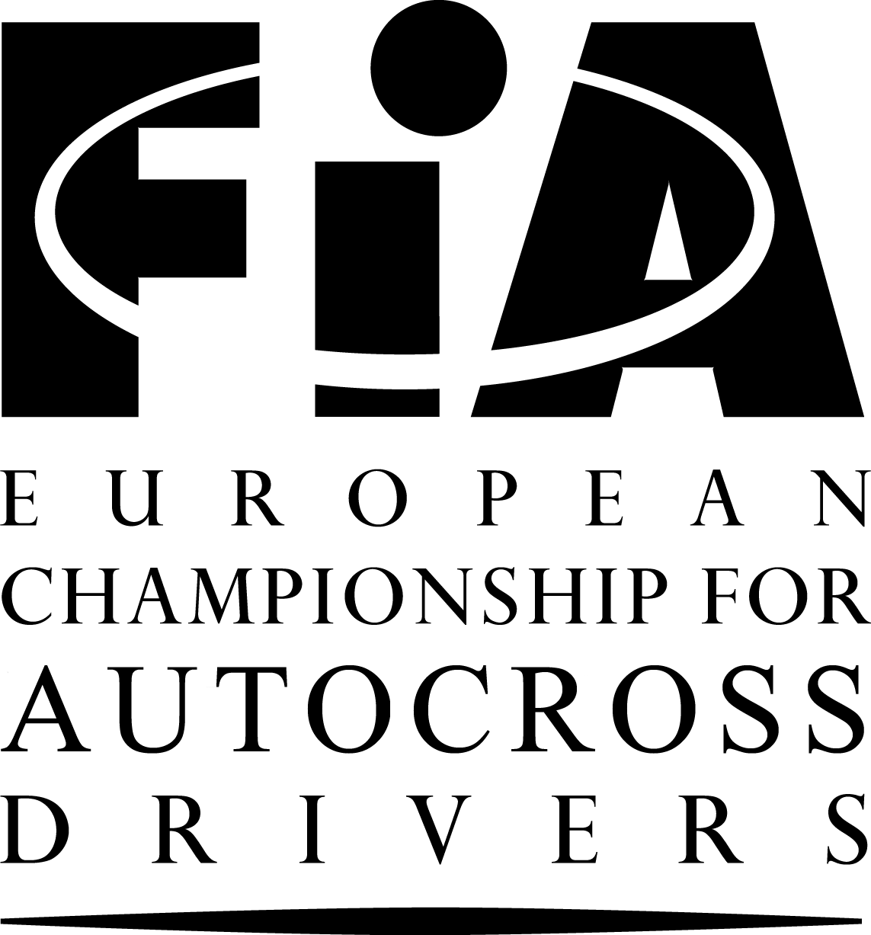
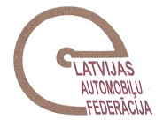

REGULATIONS
SUPPORT RACE
“LATVIAN NATIONAL CUP”
FOR AUTOCROSS DRIVERS

CHAPTERS:

I. PROGRAMME
II. ORGANISATION: Article 1
III. GENERAL CONDITIONS: Articles 2 – 8
IV. CHECKING: Articles 9 –10
V. RUNNING OF THE EVENT: Articles 11 – 17
VI. RESULTS / PROTESTS: Articles 18 – 20
VII. PRIZES AND CUPS: Article 21
VIII. OTHER INFORMATION: Articles 22 – 25

I. PROGRAMME

07.03.2011. Publication of regulations and acceptance of entries
08.05.2011. Closing date for entries at normal fee
20.05.2011. Closing date for entries at increased fees
Reservation of paddock at home page www.musa.lv or phone +371 26646484

Friday, 20.05.2011.

19:30 – 20:30 Secretariat and Scrutineering will be open
Administrative checking and scrutineering Mūsa

Saturday, 21.05.2011.

10:00 – 11:00 Administrative checking and scrutineering Mūsa
11:30 – 13:00 Free practice
13:30 – 16:30 Official timed practice
17:00 1st Heat begins

Sunday, 22.05.2011.

09.00 – 10.00 Warm up
11:00 Opening Ceremony of event
11:40 2nd Heat begins
13:30 3rd Heat begins
15:30 Finals
Podium at circuit after each A final
19:00 Prize-giving at Sporta Komplekss “Mūsa”

II. ORGANISATION

1.1 The Sporta Komplekss “Mūsa” will organise a The Latvian National Cup Event. This Event will be run in accordance with the Code (and its Appendices) of the LAF, the LAF Regulations for Autocross and these Regulations (and any other Regulations which may be issued in writing by the organisers).

1.2 Organising Committee
SPORTA KOMPLEKSS MŪSA
Organizer – Edgars Maišelis

Adress: Elijas street 17, Rīga, Latvia, LV-1050
Tel: +371 67224816
Fax: +371 67204164 Mob.tel. +371 29227172, www.musa.lv, musa@musa.lv

LATVIAN AUTOMOBILE FEDERATION
President – Jānis Naglis

Adress: Brivibas street 224, 5 building, Rīga, Latvia, LV-1039
Tel: +371 67520296
Fax: +371 67551465 Mob.tel. +371 29122228, www.laf.lv, laf@laf.lv

OFF ROAD COMMISION OF LATVIAN AUTOMOBILE FEDERATION
Chairman – Inta Ulme

Adress: Brivibas street 224, 5 building, Rīga, Latvia, LV-1039
Tel: +371 67520296
Fax: +371 67551465 Mob.tel. +371 29264457, www.laf.lv, autokross@laf.lv

1.3 Officials
Steward Aivars Liškovskis Latvia
Clerk of the Course Andrejs Voitovs Latvia
Secretary of the cup Maija Saulīte Latvia
Chief Scrutiniser Modris Volksons Latvia
Chief Timekeeper Aivars Bomis Latvia
Safety Officer Edmunds Osis Latvia
Chief Medical Officer Uģis Zeltiņš Latvia
Drivers' Liaison Officer Oskars Stūris Latvia
Press Officer Ivo Stīrijs Latvia
Start line judge and false start judge Sergejs Bednarskis Latvia
False start judge Guntis Kampe Latvia
Finish line judge Ēvalds Broks Latvia

  - Official Notice Board
The official notice board will be located in the paddock near race centre.

III. GENERAL CONDITIONS

2. GENERAL
2.1. This Event will count for:
- The Latvian National Cup - Support race

3. DESCRIPTION OF THE CIRCUIT
Place: “Mūsa”, Bauska region, Latvia
Telephone: Mob. Tel: +371 29253024
Length: 940 metres
Width of start: 15 metres
Maximum width: 22 metres
Minimum width: 13 metres
Location: Road A7 Rīga – Vilnius 71km (GPS coordinates: 56.381847,24.259438)

Information about location is available in home page www.musa.lv

4. ELIGIBLE VEHICLES
4.1. The Latvian National Cup Event is open to vehicles which is participate in National championships for autocross in following divisions: B – 600.
4.2. Each car will be accompanied by a National Technical Passport.

5. ELIGIBLE COMPETITORS
Any person or body holding a National or International Drivers Licence.

6. ENTRY FORMS – ENTRIES
6.1. Anybody wishing to take part in the Event must send the attached entry form duly completed to
the Secretariat at

SPORTA KOMPLEKSS “MŪSA”
Adress: Elijas street 17, Rīga, Latvia, LV-1050
Tel: +371 67224816
Fax: +371 67204164 Mob.tel. +371 26646484, musa@musa.lv, www.musa.lv.
Before 08.05.2011.

6.2. There will be only one driver per car, and no driver may compete in more than one car at the Event.
6.3. The Organising Committee reserves the right to refuse the entry of a competitor or a driver without having to give the reason (Article 74 of the Code).
6.4. The maximum number of entries for a Support race will be 20.

7. ENTRY FEES
7.1. The entry fee is:
a) Before 08.05.2011. - € 100.00
b) Before 20.05.2011. - € 150.00

7.2 No car will be allowed to start unless the entry fees have been paid in full.
7.3. Additional fees may be payable by a competitor who refuses to carry the organiser’s advertising.
- € 200.00

8. INSURANCE
The organizer guarantees for competitors of European Championship for autocross event in “Sporta Komplekss Mūsa” the civil responsibility insurance.
Policy number 172840698, date: 02.02.2011.
Insurance company: AAS “BALTA”, limit of insurance: 100 000.00 Ls

IV. CHECKING

10. SCRUTINEERING
10.2 Noise
For all cars, a limit of 100 dB is imposed.

V. RUNNING OF THE EVENT
14. QUALIFYING
There will be 5 laps in the qualifying Heats.

15. FINALS
There will be 7 laps in the Finals.

VI. RESULTS – PROTESTS
- PROTESTS – APPEALS
20.1 All protests will be lodged in accordance with the Code.
All protests must be made in writing and handed to the Clerk of the Course or his assistant, or in their absence any of the Stewards of the meeting, together with the sum of € 500. If the protest requires the dismantling and re-assembly of different parts of a car, the claimant must make a deposit of € 500.

20.5 Competitors have the right to appeal, as laid down in Articles 181,182 and 183 of the Code and also as set out in the Rules of the International Court of Appeal. The amount of the appeal fee is € 600.

- PRIZES AND CUPS

21. PRIZES
The prize-giving will take place at Sporta Komplekss “Mūsa” at 19:00.
The prizes will be awarded in Euros- €.
First five places will be rewarded with cups and 1st - 3 rd of them will rewarded with award.
Prize fund net of taxes:
1st place – € 150.00
2nd place – € 120.00
3rd place – € 100.00

- OTHER INFORMATION

22. FIRE EXTINGUISHERS
Each driver is responsible for ensuring that a single piece extinguisher of minimum 5 kg is available within his own team area inside the paddock.

23. Protection of the environment
Each driver is requested to ensure that a plastic sheet (minimum dimensions 4 metres by 5) is spread on the ground in the place reserved for his team where work is to be done on his car, in order to prevent any pollution in case of an accidental leak, etc.
Cars are allowed wash only at the place, which is appointed by the organiser.

24. DRIVERS’LIAISON OFFICER
The Drivers’ Liaison Officer will be recognisable by special red vest. The Driver’s Liaison Officer will present a shedule of his duties, which shall also be posted on the Official Notice Board of the event.
He may be reached near race center.

HOTELS

Hotel reservations can be made directly to the
- Bauska region – Hotel “Bērzkalni” – 3 km from Musa
Tel. +371 63926888, www.berzkalni.lv, hotel@berzkalni.lv
Reservation and information at reception

TRAVELLING

If there is necessity for Latvian visa, please contact with Latvian Automobile Federation,
Tel. +371 67520296, Mob. Tel. +371 29122228, or Fax: +371 67551465
Cars are allowed in paddock with passes which will be given at the secretariat.

