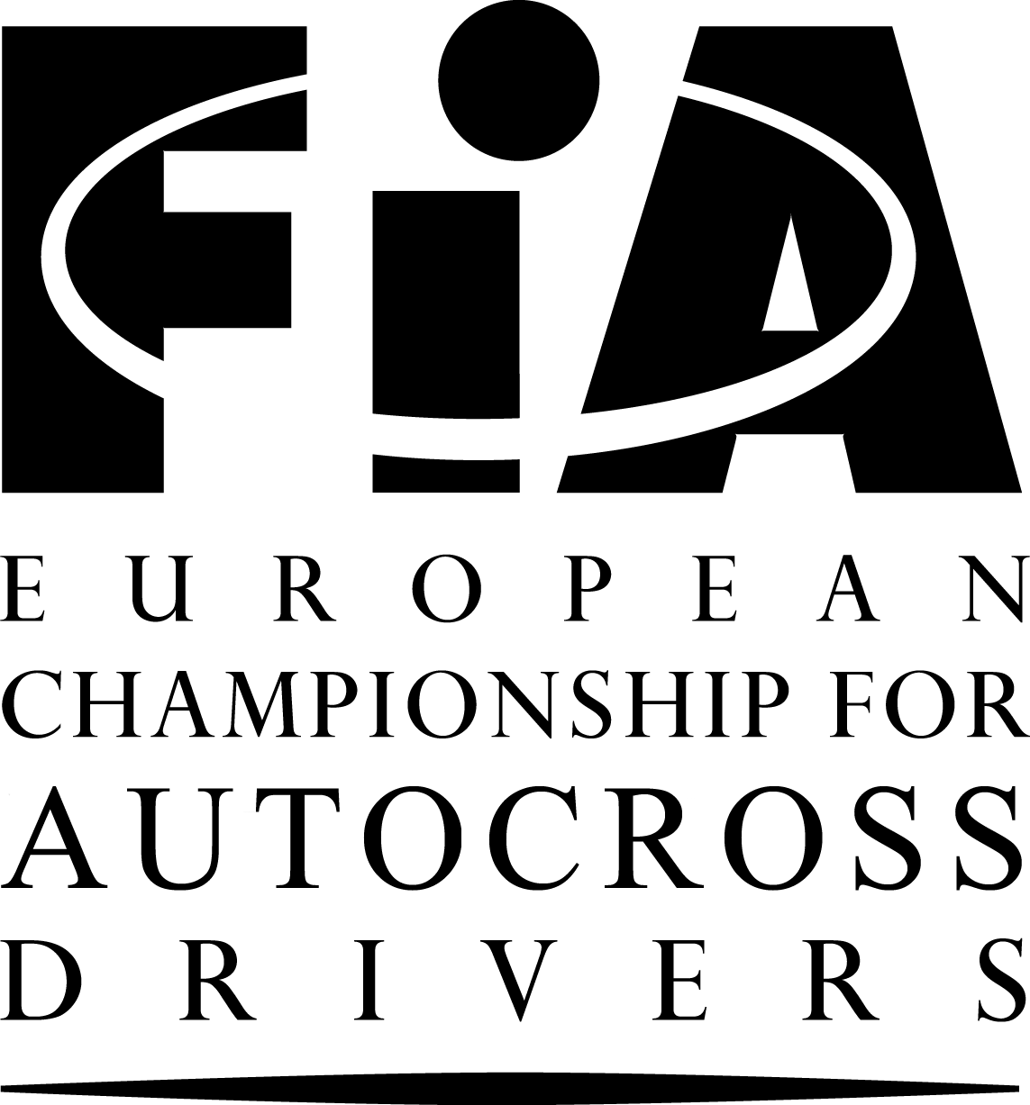


SUPPLEMENTARY
REGULATIONS FOR EVENTS OF THE FIA EUROPEAN CHAMPIONSHIP
FOR AUTOCROSS DRIVERS
- SHORT VERSION 2011 -

This document contains the particularities of the event and is based on the currently valid Appendices to the International Sporting Code and on the newest version of the Standard Regulations for Events of the FIA European Championship for Autocross Drivers. For all articles not specified in this document, the Standard Regulations for Events of the FIA European Championship for Autocross Drivers are valid. The Standard Regulations are distributed to each competitor in the FIA European Championship by his ASN. They are also posted on the Official Notice Board of each event. The numbering of the chapters is in accordance with the Standard Regulations.

CHAPTERS:

I. PROGRAMME
II. ORGANISATION: Article 1
III. GENERAL CONDITIONS: Articles 2-8
IV. CHECKING: Articles 9-10
V. RUNNING OF THE EVENT: Articles 11-17
VI. PARC FERME / RESULTS / PROTESTS: Articles 18-20
VII. PRIZES AND CUPS: Article 21
VIII. OTHER INFORMATION: Articles 22-25

I. PROGRAMME

07.03.2011. Publication of regulations and acceptance of entries
08.05.2011. Closing date for entries at normal fee
20.05.2011. Closing date for entries at increased fees
Reservation of paddock at home page www.musa.lv or phone +37126646484
Friday, 20.05.2011.

18:00 – 20:00 Secretariat and Scrutineering will be open
Administrative checking and Scrutineering at Musa
Saturday, 21.05.2011.

08:00 – 10:00 Administrative checking and Scrutineering at Musa
11:00 First Stewards Meeting
11:30 – 13:00 Free practice
13:30 – 16:30 Official timed practice
Second Stewards Meeting (10 min. after Official timed practice)
17:00 1st Heat begins

Sunday, 22.05.2011.

11:00 Opening Ceremony of event
11:40 2nd Heat begins
13:30 3rd Heat begins
Third Stewards Meeting (10 min. after 3rd Heat)
15:30 Finals
Podium at circuit after each A final
Fourth Stewards Meeting (immediately after finals)
19:00 Official Prize Giving at Musa

II. ORGANISATION

1.1 The “Sporta Komplekss Mūsa” will organise an FIA European Autocross Championships Event. This Event will be run in accordance with the Code (and its Appendices) of the FIA, the FIA Regulations for Autocross, General Prescriptions for the Championship and these Regulations (and any other Regulations which may be issued in writing by the organisers).

1.2 Organising Committee

SPORTA KOMPLEKSS MŪSA
Organizer – Edgars Maišelis

Adress: Elijas street 17, Rīga, Latvia, LV-1050
Tel: +371 67224816
Fax: +371 67204164 Mob.tel. +371 29227172, www.musa.lv, musa@musa.lv

LATVIAN AUTOMOBILE FEDERATION
President – Jānis Naglis

Adress: Brivibas street 224, 5 building, Rīga, Latvia, LV-1039
Tel: +371 67520296
Fax: +371 67551465 Mob.tel. +371 29122228, www.laf.lv, laf@laf.lv

OFF ROAD COMMISION OF LATVIAN AUTOMOBILE FEDERATION
Chairman – Inta Ulme

Adress: Brivibas street 224, 5 building, Rīga, Latvia, LV-1039
Tel: +371 67520296
Fax: +371 67551465 Mob.tel. +371 29264457, www.laf.lv, autokross@laf.lv

1.3 Officials
- Chairman of the Stewards Bengt-Goran Grenander Sweden
- Steward Peter Faluvegi Hungary
- Steward Arnis Vēza Latvia
- FIA Observer Wlodek Szaniawski Poland
- FIA Technical Delegate Lutz Speer Germany
- Clerk of the Course Gunārs Kosojs Latvia
- Secretary to the Stewards Linda Cepurniece Latvia
- Assistant Clerk of the Course Andrejs Voitovs Latvia
- Secretary of the meeting Maija Saulīte Latvia
- Chief Scrutineer Aivars Liškovskis Latvia
- Chief Timekeeper Aivars Bomis Latvia
- Safety Officer Edmunds Osis Latvia
- Chief Medical Officer Uģis Zeltiņš Latvia
- Drivers' Liaison Officer Oskars Stūris Latvia
- Press Officer Ivo Stīrijs Latvia
- Judges of fact: - startline Sergejs Bednarskis Latvia
- false start Guntis Kampe Latvia
- finish Ēvalds Broks Latvia

1.4 Official Notice Board
The official notice board will be located in the paddock near race centre.

III. GENERAL CONDITIONS

2. GENERAL
2.1 This Event will count for:
- The 2011 FIA European Autocross Championships for Drivers
- The 2011 FIA Autocross Nations Cup
- The 2011 FIA Junior Buggy CUP
- Latvian National Cup – Support race

3. DESCRIPTION OF THE CIRCUIT
Place: “Mūsa”, Bauska region, Latvia
Telephone: Mob. Tel: +371 26646484
Length: 940 metres
Width of start: 15 metres
Maximum width: 22 metres
Minimum width: 13 metres
Location: Road A7 Rīga – Vilnius 71km (GPS coordinates: 56.381847,24.259438)

Information about location is available in home page www.musa.lv

5. ENTRY FORMS – ENTRIES
5.1 Anybody wishing to take part in the Event must send the attached entry form duly completed to the Secretariat at
SPORTA KOMPLEKSS MŪSA
Address: Elijas street 17, Rīga, Latvia, LV-1050
Tel: +371 67224816
Fax: +371 67204164 Mob.tel. +371 26646484, musa@musa.lv, www.musa.lv.
Before - 08.05.2011.

5.8 The maximum number of starters will be 80 a total.
The maximum number of entries for a support race will be 20.

6. ENTRY FEES
6.1 The entry fee is:
a) 1st closing date of entries: 150 € (Entry fee 100 € + 50 € paddock fee – all included)
100 € (Entry fee € 50 + € 50 paddock fee – all included). – Junior Buggy
b) 2nd closing date of entries: 250 € (Entry fee 200 € + 50 € paddock fee – all included)
As the Entry Form from the Driver and the Confirmation of the acceptance from the Organiser is considered as a contract, the Driver, not coming to the Event, has to apologise giving the reason as soon as possible. The Entry Fee will be paid at the Administrative checking.

6.2 The additional fee for competitor who refuses to carry the organiser`s sponsor`s advertising:
- € 200

7. INSURANCE
The organizer guarantees for competitors of European Championship for autocross event in “Sporta Komplekss Mūsa” the civil responsibility insurance.
Policy number 172840698, date: 02.02.2011.
Insurance company: AAS “BALTA”, limit of insurance: 100 000.00 Ls

IV. CHECKING

10. SCRUTINEERING
10.2 Noise
For all cars, a limit of 100 dB is imposed.

V. RUNNING OF THE EVENT

12. PRACTICE AND DRIVERS' INFORMATION
12.1 Free practice and two qualifying practice sessions, one organised in order of the numbers and the second in reverse order, are obligatory in each Division. The free practice session will be run over 4 laps minimum.
There must be no more than 1 car at each 120m of the track in each qualifying practice session, which will last for 5 laps from the entry of the first car onto the track, but only the times starting from the 2nd lap will count.
The best lap time from all the qualifying practice sessions determines the starting positions for the first Heat. In the event of a tie, the next best lap time of the drivers who have tied determines the starting positions.
Each driver must complete at least one lap in practice. Should this not be the case, the driver may be allowed to start in the first qualifying Heat, at the discretion of the Stewards. Cars from different divisions will run separately.
12.2 Information in English and optionally in the host language of the Event will be given in writing to all drivers at the administrative checking.

14. QUALIFYING
There will be 5 laps in the qualifying Heats.

15. FINALS
There will be 7 laps in the Finals.

VI. PARC FERME – RESULTS – PROTESTS

- PROTESTS – APPEALS
20.1 All protests will be lodged in accordance with the Code.
All protests must be made in writing and handed to the Clerk of the Course or his assistant, or in their absence any of the Stewards of the meeting, together with the sum of € 500. If the protest requires the dismantling and re-assembly of different parts of a car, the claimant must make a deposit of € 500.

20.5 Competitors have the right to appeal, as laid down in Articles 181,182 and 183 of the Code and also as set out in the Rules of the International Court of Appeal. The amount of the appeal fee is € 1000.

VII. PRIZES AND CUPS
21. PRIZES
The podium ceremony on the circuit will be held immediately after the races. The winners of the 1st, 2nd and 3rd prizes must be present wearing their race overalls. Failure to attend this ceremony will be penalized by the loss of any monetary award / benefit associated with the corresponding position at the end of the race.
The prize-giving will take place at Sporta Komplekss Mūsa at 19:00.
The prizes will be awarded in Euros. Prize fund net of taxes distributed:

Classification | Super Buggy | Buggy 1600 | Touring AX | Junior Buggy
1st | EUR 600 | EUR 500 | EUR 400 | EUR 300
2nd | EUR 550 | EUR 450 | EUR 350 | EUR 250
3rd | EUR 500 | EUR 400 | EUR 300 | EUR 200
4th | EUR 450 | EUR 350 | EUR 250 | EUR 150
5th | EUR 400 | EUR 300 | EUR 225 | EUR 100
6th | EUR 350 | EUR 275 | EUR 200 | EUR 100
7th | EUR 300 | EUR 250 | EUR 175 | EUR 100
8th | EUR 250 | EUR 200 | EUR 150 | EUR 100
9th | EUR 200 | EUR 150 | EUR 125 | EUR 100
10th | EUR 150 | EUR 125 | EUR 100 | EUR 100

VIII. OTHER INFORMATION
22. FIRE EXTINGUISHERS
Each driver is responsible for ensuring that a single piece extinguisher of minimum 5 kg is available within his own team area inside the paddock.

23. Protection of the environment
Each driver is requested to ensure that a plastic sheet (minimum dimensions 4 metres by 5) is spread on the ground in the place reserved for his team where work is to be done on his car, in order to prevent any pollution in case of an accidental leak, etc.

24. DRIVERS’LIAISON OFFICER
The Drivers’ Liaison Officer will be recognisable by special red vest. The Driver’s Liaison Officer will present a shedule of his duties, which shall also be posted on the Official Notice Board of the event.
He may be reached near race center.

25. AUTHORISATION
These Regulations have been agreed by (ASN) Latvian Automobile Federation on 03.01.2011.
The FIA Visa n° is: …..... .

HOTELS

Hotel reservations can be made directly to the
- Bauska region – Hotel “Bērzkalni” – 3 km from Musa
Tel. +371 63926888, www.berzkalni.lv, hotel@berzkalni.lv
Reservation and information at reception

TRAVELLING

If there is necessity for Latvian visa, please contact with Latvian Automobile Federation,
Tel. +371 67520296, Mob. Tel. +371 29122228, or Fax: +371 67551465
Cars are allowed in paddock with passes which will be given at the secretariat.

